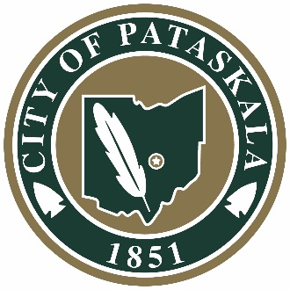

CITY OF PATASKALA

COUNCIL PUBLIC HEARING

April 5, 2021

The Council of the City of Pataskala held a Public Hearing on April 5, 2021 at 6:50 PM at City Hall located at 621 W. Broad Street. Pledge of Allegiance was given. Roll Call: Carter, Walther, Epperson, Barstow, Hampshire, and Galik were present. Lee was absent. Mayor Michael W. Compton presiding and Brian Zets, Law Director was present.

Mayor Compton stated, “Purpose of this public hearing is to consider the following application:

Application for an Agricultural District, submitted by Barbara A. Jacobs, Trustee, 4473 Columbia Rd., Pataskala, Ohio, 43062-8713 for Parcel Number 063-140202-00.000 and Parcel Number 063-140196-00.000 located in the City of Pataskala, Licking County, Ohio.”

Scott Fulton, Planning Director provided a general review of the application. Mr. Fulton indicated that staff has no objections to this application.

Galik reported that the Agriculture Committee had no comments or concerns with this application.

Barstow made a motion to adjourn. Seconded by Epperson. Roll Call: Carter, Walther, Epperson, Barstow, Hampshire, and Galik-yes. Mayor Compton declared the motion passed.

Meeting Adjourned.

Minutes approved __________________, 2021.

_______________________________ _________________________________
Kathy M. Hoskinson, Clerk of Council Todd Barstow, Council President

